


WINTER 2013
WINTER 2013

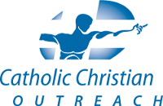

1247 Kilborn Place
Ottawa, ON K1H 6K9
www.cco.ca

(613) 736-1999
(250) 899-1948 (cell)
lindsay.rigby@cco.ca

Catholic Christian Outreach (CCO) is a university student movement dedicated to evangelization. We challenge students to live in the fullness of the Catholic faith, with a strong emphasis on becoming leaders in the renewal of the world.

SYNOD NEWS

In October 2012, 262 Bishops from around the world gathered in Rome for the Synod on the New Evangelization.

At this important moment in the life of the Church, CCO sent its leaders to Rome to be part of the events and to lead a symposium for lay movements currently active in the New Evangelization.

We have a sense that Lord has chosen us to be a catalyst, to be a movement that causes something important to happen, to help the whole Church to rise in its potential.

The entire Synod experience was blogged by members of CCO's senior leadership team.

Discover more at:
http://synodblog.cco.ca.

“If you are what you should be, you will set the whole world ablaze.” – St. Catherine of Siena

Dear St. Charles Garnier parish family:

Greetings from Ottawa! I'm writing to share some highlights from the past semester. I remain grateful for your continued support, both prayerful and financial, and am thankful for all there is to celebrate!

Fall Semester Faith Studies Across Canada – This past semester there were 680 students on CCO campuses in Faith Studies. Of the 380 Discovery faith studies, about 70 are lead for students by students. As you may recall, Discovery is the first of CCO's five studies. It presents the basic Gospel message and invites students to choose to accept the salvation Jesus offers and put Him at the centre of their lives. Our goal is to have the students we work with make this decision for Christ, then go out and help other students to do the same. The fact that so many students are leading this Discovery study means they are living out what it means to be Catholic: to know and love God and to want to make Him known and loved by others. They are reaching out to those around them and inviting them into a personal and intimate relationship with Jesus.

Seven-to-Seven for Campus Evangelization – It is during the fifth week of Discovery that students are explicitly invited to make a choice for Christ. This is a very critical time, in which all of CCO – our staff, students and supporters – are encouraged to intercede in prayer.

Here in Ottawa, a handful of student leaders
at the University of Ottawa took their heart for
evangelization a step further by organizing a
Seven-to-Seven -- a 12-hour, overnight vigil of
fasting and prayer. My housemates, two of whom
are also missionaries with CCO, and I, along with
some other campus ministers, participated along-
side the students. It was very heartening to
witness the faith and genuine care that these
young men had for the participants in the studies
they were leading. And they were not only willing,
but also enthusiastic to be heroic in their prayer!
The event was also a great opportunity for me to
get to get to know them personally, and to hear
how the Lord is working in each of their lives.

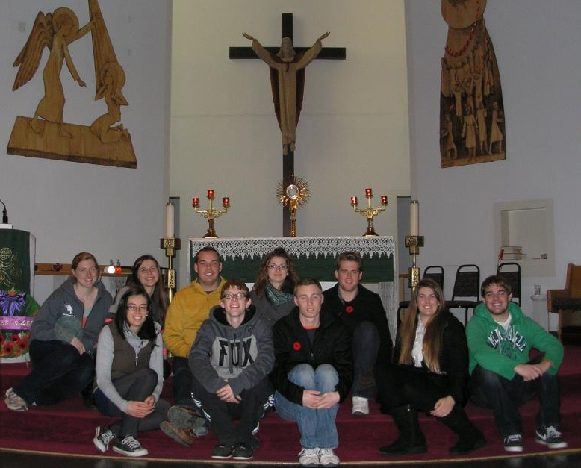


Leading Discovery: An Invitation

In celebration of CCO’s 25th Anniversary year (2013) we are launching a new initiative: Leading Discovery. This year, we are challenging our supporters and alumni to take Discovery beyond campus and bring it into our parishes, workplaces, and circles of friends. I would like to invite you to consider leading your own Discovery faith study. To aid you in doing this we have a wonderful resource set up: www.leadingdiscovery.ca.

On this website you will find links to interactive training videos, testimonies of others who are leading Discovery, links to buy faith studies. You can also share you stats so we can see how many people are hearing the Gospel proclaimed through this initiative! The website was designed to be easy to use, even if you aren’t computer savvy, so please check it out! I especially encourage you look at the interactive training, as it is very clear and helpful. If you are interested in leading a Discovery faith study and have any questions or just need some help getting started please let me know. I would love to help you!

We are expanding! Following a formal invitation by the Archbishop of Toronto, CCO is pleased to announce that its mission will formally expand to Ryerson University in the Fall of 2013! This will be the tenth campus where CCO missionary teams will be present. CCO hopes to contribute to the current campus ministry efforts through our specific mission of evangelization and leadership development.

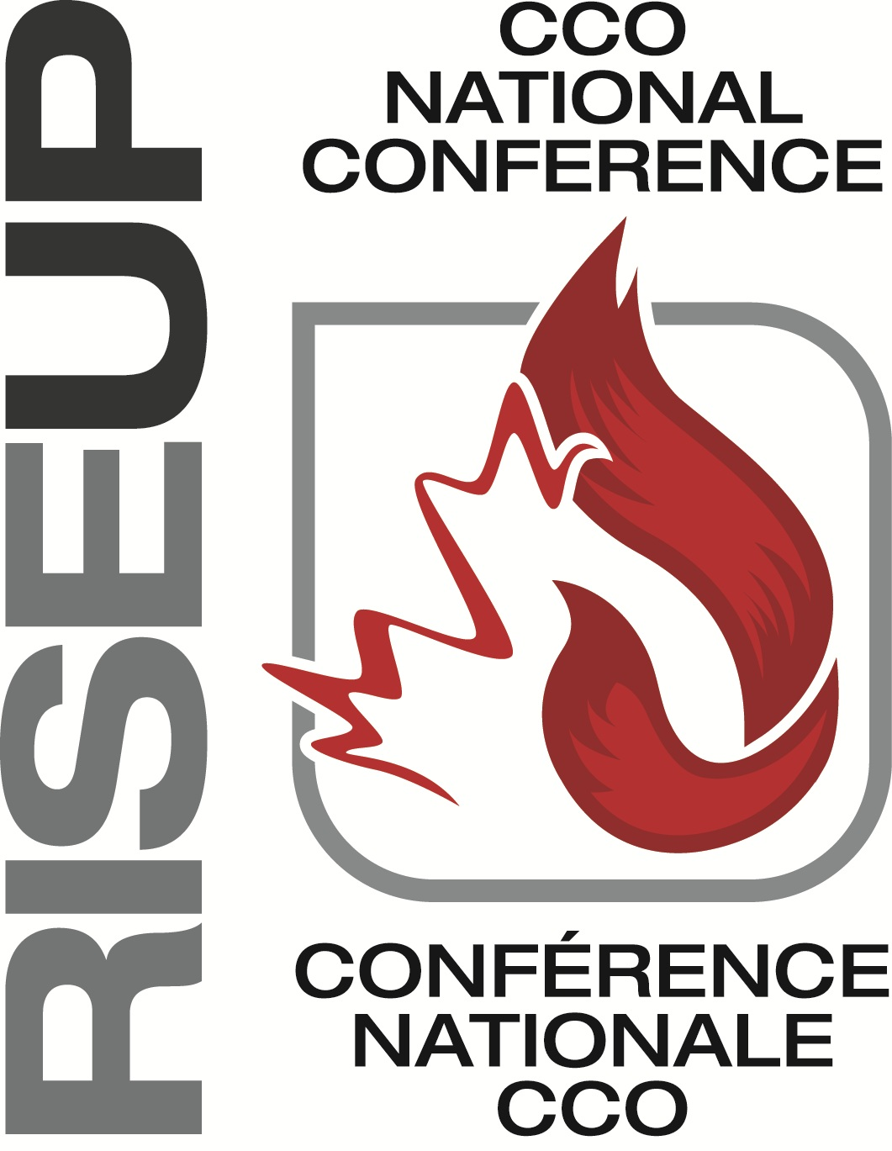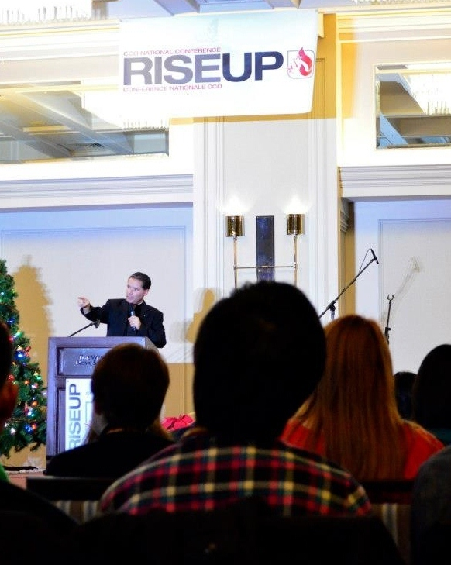
Student Reaching Student:
stories from the Campus Mission Field

University of Ottawa

Alex is a student that left her contact information with us when we did our initial outreach at clubs week at the beginning of the Fall semester. One of our missionaries made repeated attempts to contact her, but was unsuccessful. Meanwhile, one of our students got to know her (as his lab partner) over the semester, and found out that she had a fear of dying. Through their friendship he was able to introduce her to a CCO missionary -- who turned out to be the very same one who had been trying to connect with her since September! Alex apologized for deliberately avoiding the missionary. They took some time to talk about Alex’s fear. The CCO missionary was able to share God’s invitation for a personal relationship (through the Ultimate Relationship booklet) with her and taught her how to pray the rosary. She is looking forward to building the relationship with Alex, and seeing how God will continue to bring her closer to Him!

University of British Columbia

Jenn, a student we mentor at UBC, lead a Discovery faith study last semester. After the 5th lesson, she met with her participants individually to invite them to choose to place Christ at the center of their lives. One of the ladies in her study was really struggling with the choice. She had seen God work in her life, but still had a number of doubts. Jenn prayed for her and talked through these things with her for two-and-a-half hours. The girl decided to make her relationship with Jesus her highest priority and come back to the Church. She went to Confession for the first time and is looking to join an RCIA group so she can be confirmed next Easter!

RISE UP National Conferences – In December, I travelled to Halifax, Nova Scotia, where CCO held the east-coast edition of our annual RISE UP conference. The largest Catholic young adult conference in Canada, RISE UP is designed to motivate and inspire leaders for the renewal of the world. Over 250 young adults joined us for four impactful days of talks, workshops, sacraments, worship, and fellowship. In Saskatoon, 300 more students were participating in the west-coast RISE UP. Although held in two different cities, the conferences were united in prayer and under a single theme, Fiat: A Yes Can Change the World. Many life-changing experiences with the Lord have happened at RISE UP, or have come as a direct result of attending. As you may recall, it was at last year’s conference in Vancouver that I received my call to join CCO’s staff!

Casa Maria – On a personal note, I am currently living with three other women. Mallory (below, far left) is a first-year CCO staff member at Carleton University, and Megan (far right) is a second-year staff member at the University of Ottawa. Michelle (middle, right) was involved with CCO as a student and continues to share in our charism and mission by leading weekly faith studies. They are such a blessing to me and living with them allows me to stay close and connected to what’s happening on campus. We often have students over individually, or in groups, to share meals or for Women’s Nights or book studies. The opportunity to get to know students on a one-on-one basis and share in their faith journeys is a wonderful privilege and brings a joyful, life-giving context to the work that I do in the office. In honour of our Blessed Mother, the Mystical Rose, we’ve named our home ‘Casa Maria’ and have placed ourselves under her patronage. Rosa Mystica, ora pro nobis!

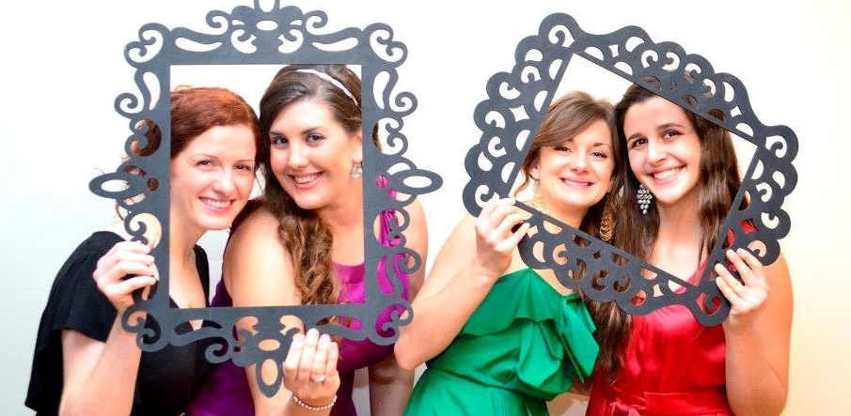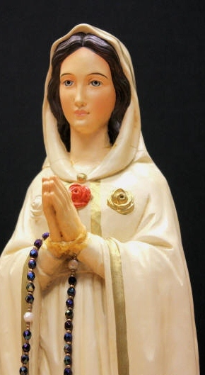

Thank you for your participation in our mission by means of your prayers and financial support. Please continue to pray for me, for CCO, and for the hearts of our students as they respond with courage and love to the demands of the Gospel.

Yours in Christ,
Lindsay
Lindsay Rigby
CCO Missionary,
National Headquarters, Ottawa

As you might imagine, the Fall term is a very busy time for CCO. On campus, our missionary staff and student leaders invite other students to fill out faith surveys and ask them leave their contact information. We follow-up with each person directly, so that we can present the Gospel message, clearly and simply, to one person at a time. Students are then invited to join a faith study, which meets for one hour a week over the course of the semester. Each of our five faith studies (see sidebar) is designed to bring people to Christ, build them up as Catholic Christians, and send them out to reach others.

Day-to-day, I’m based at CCO’s national headquarters in the Archdiocesan Pastoral Centre. During my initial internship year, I’ve been assigned to work on special projects for the Finance team and will move into Stewardship and Development full-time next spring. Here in the office, I’m able to live out my call to mission in a more “hidden” way, using my education, skills, and experience to support (and intercede for) campus evangelization and to help lead the movement at a national and international level. However, I also have opportunities to engage in direct ministry.

In September, I joined the Ottawa district campus team in facilitating the annual Fall Retreat attended by approximately 75 university students from the area. The theme was “Follow Me,” based on Christ’s words as He called the apostle Matthew. Many of the students experienced profound conversions and a deepening of their relationship with the Lord, especially during the evening of Eucharistic Adoration, Praise and Worship, and Reconciliation, which was the cornerstone of the retreat.

In October, I assisted at Night Fever, an event that originated in Germany shortly after the XX World Youth Day in Cologne. We gathered at Sacré-Coeur Church near the University of Ottawa campus and invited passers-by off the street to come into the sanctuary to light a candle at the altar, where the Blessed Sacrament was exhibited in the monstrance. Priests were available for confession. From that event, over 150 people came into the church and eight people signed up for Faith Studies!

“The mission of Christ the Redeemer, which is entrusted to the Church, is still very far from completion. […] [W]e must commit ourselves wholeheartedly to its service.” – Bl. John Paul II, Redemptoris Missio

